Scentless Chamomile (Matricaria perforata)
Scentless chamomile is a member of the Aster family that was imported from Europe as an ornamental and now grows worldwide. It is an annual that grows ½ foot to 2 feet tall in a bushy shape with showy white flowers. It is nearly identical in appearance to the strong scented species, but can be easily distinguished by its lack of odor. Scentless chamomile has no forage value and can cause blistering of muzzles, irritation of mucous membranes, and skin rashes in livestock and wildlife. The plant has become widely established in the City of Aspen and Town of Snowmass Village. A single plant can produce as many as a million seeds. One flower head can have as many as 300 seeds, and the seed can remain airborne for up to 12 hours.

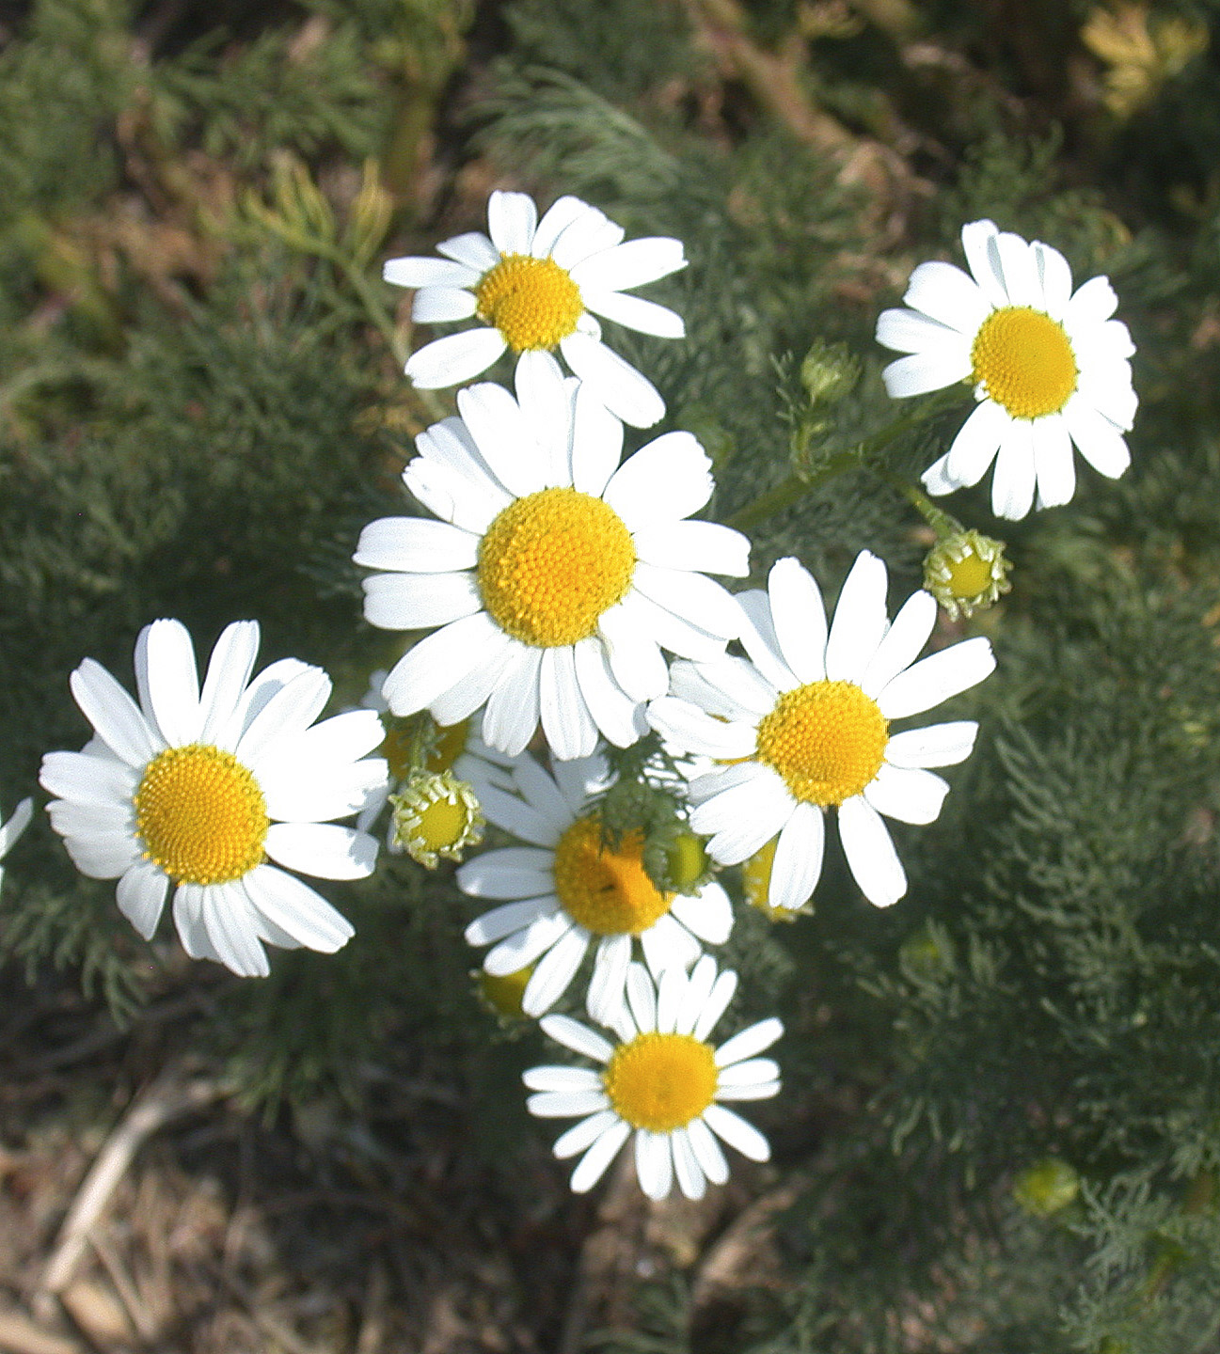

Oxeye Daisy (Chrysanthemum leucanthemum)
Oxeye daisy, a member of the Aster family, is a native of Eurasia. It is an erect perennial plant with characteristic “daisy-like” flowers (white ray and yellow disk flowers) which bloom from June through August. Oxeye daisy is commonly sold (illegally!) in wildflower seed mixes or transplanted as an ornamental despite its tendency to aggressively crowd out more desirable vegetation. Plants initially develop as a basal rosette. Lower rosette leaves occur on petioles and are from 1 1/2 to 6 inches long.
Wildlife and livestock do not like to graze or walk through an area infested with Oxeye daisy since the plants irritate their legs and faces. Very few animals will eat oxeye daisy and oxeye daisy infestations supplant plants that wildlife prefer to eat, resulting in reduced wildlife habitat. Because oxeye daisy is such a showy, pretty plant, proper management is often neglected. Oxeye daisy should be mowed as soon as flowers appear to reduce seed production. Root systems are shallow and the plant can be dug up and removed. Hand removal will have to be continued for several years because seeds may remain viable in the soil for a long time before they germinate. Several herbicides are also effective.
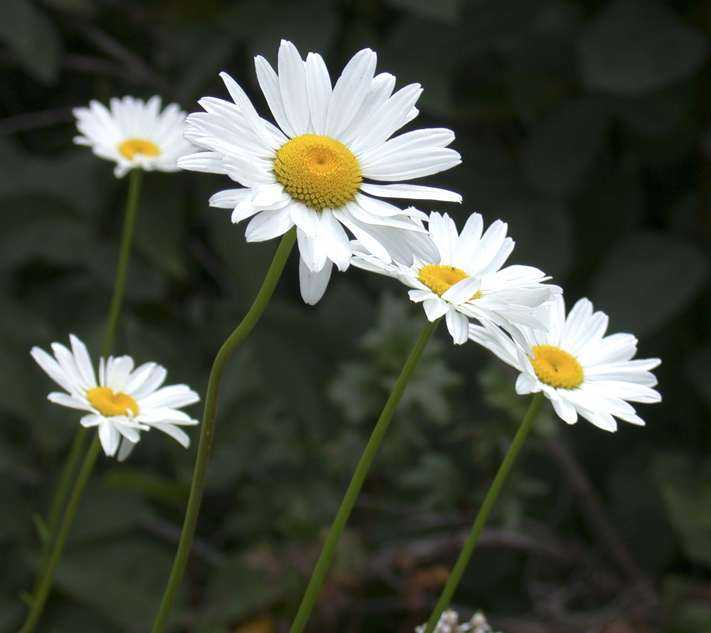

For additional information, contact Pitkin County Land Management at 920-5214 or the City of Aspen Parks Department at 429-2026.

